American Charitable Watersport Activities Foundation 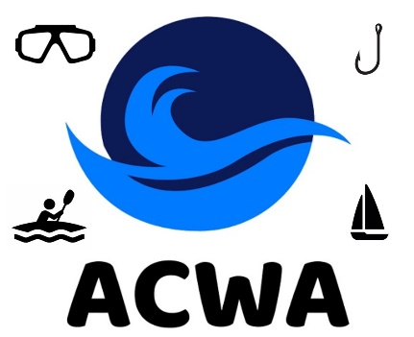
2024 Supporter Registration
The “American Charitable Watersport Activities Foundation” (ACWA) was established by SCUBA divers on March 31, 2023. ACWA is recognized by the IRS as a 501(c)(3) public non-profit charity. Staffed by non-paid volunteers, ACWA’s administrative and donation support is provided annually by members of our community.
Supporter Registration for the “American Charitable Watersport Activities Foundation” (ACWA) is open to Dive Clubs and Individuals who reside in the United States of America. 2024 registration is $20.
“Supporters” on record for 2023 are listed on a “Supporter Master List” and need not complete this form. They continue their charity efforts with their 2024 payment of $20 to ACWA’s treasurer - Mark Leiserowitz (contact information listed below).
New “Supporters” need to complete this form to provide ACWA with contact and IRS reporting information. To join as an individual (must be a certified scuba diver, or a member of a dive club) - fill out the application below. Please print legibly as e-mail addresses will be utilized to keep supporters abreast with the charity’s status and your name as identified below, used in any future donation reporting required by you or the IRS.

Dive Club _______________________________________________
or
Certifying Agency: _____________________________ C-Card Number: _________________________

Make Checks Payable To: TGCC, c/o Mark Leiserowitz, 5205 De Milo Dr., Houston, Texas 77092
Name: _____________________________________Phone / Cell Phone: ________________________
E-Mail: _______________________________________________________________
Signature: ____________________________________________ Date: ________________________

