American Charitable Watersport Activities Foundation 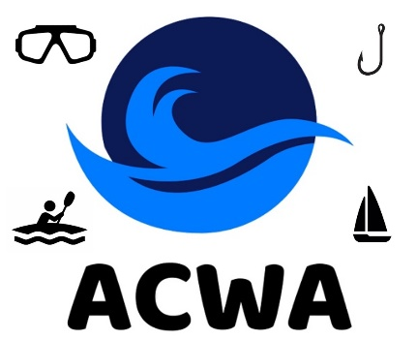
Donation Form
The “American Charitable Watersport Activities Foundation” (ACWA) was established by SCUBA divers on March 31, 2023. ACWA is recognized by the IRS as a 501(c)(3) public non-profit charity that is staffed by non-paid volunteers. There are no “administrative” charges.
ACWA has two donation options for individuals or companies – as a “Donner” or as a “Target Donner”.
Donation made as a “Donner” – A payment made to ACWA to support ACWA’s charity program.
Donation made as a “Target Donation” – A payment made to ACWA with instructions for ACWA to adjust its current charity program. “Target Donations” are reviewed by ACWA prior to their acceptance - to ensure that their target is in compliance with ACWA’s 501(c)(3) scope and objectives.
Donation Application
Donation $_______ or Target Donation $_________. Target __________________________________
If not cash, describe the Target Donation’ description and its value – ___________________________
____________________________________________________________________________________
____________________________________________________________________________________.

For coordination on Target Donations contact Martin Daniels (martin.daniels3@gmail.com)

Make Checks Payable To: ACWA, c/o Mark Leiserowitz, 5205 De Milo Dr., Houston, Texas 77092
Name: _____________________________________Contact Phone # ________________________
E-Mail: ________________________ Signature: _____________________________ Date: _________________

